

Foundations of Programming
Assignment No. : 5
PROBLEM STATEMENT:
Write a program in C to perform basic matrix operations such as:
1. Addition of two matrices
2. Saddle point of a matrix
3. Inverse of a matrix
4. Magic square of a matrix

OBJECTIVE:
• To understand matrix representation in C using two-dimensional arrays.
• To implement various matrix operations using C programming.
• To develop logical thinking for solving matrix-based problems.

THEORY:
Matrix operations are widely used in engineering and scientific applications. Addition of matrices involves adding corresponding elements. A saddle point is an element that is the minimum in its row and maximum in its column. The inverse of a matrix exists only for square matrices with non-zero determinant. A magic square is a square matrix in which the sums of elements in each row, column, and diagonals are equal. (ADD Example for 1. Addition of two matrices
2. Saddle point of a matrix
3. Inverse of a matrix
4. Magic square of a matrix
)

PLATFORM:
Linux

ALGORITHM:
1. Start
2. Read the order of the matrix
3. Read elements of the matrices
4. Perform matrix addition
5. Check for saddle point
6. Find inverse of the matrix (if determinant ≠ 0)
7. Check whether the matrix is a magic square
8. Display results
9. Stop

C PROGRAM: (Type C Program)

INPUT:
Matrix elements entered by the user.
#include <stdio.h>

int main() {
int i, j, r, c;

printf("Enter rows and columns: ");
scanf("%d %d", &r, &c);

int A[10][10], B[10][10], C[10][10];

// Input matrix A
printf("Enter Matrix A:\n");
for(i=0;i<r;i++){
for(j=0;j<c;j++){
scanf("%d",&A[i][j]);
}
}

// Input matrix B
printf("Enter Matrix B:\n");
for(i=0;i<r;i++){
for(j=0;j<c;j++){
scanf("%d",&B[i][j]);
}
}

// Addition
printf("\nAddition:\n");
for(i=0;i<r;i++){
for(j=0;j<c;j++){
C[i][j] = A[i][j] + B[i][j];
printf("%d ", C[i][j]);
}
printf("\n");
}

// Saddle point
int found = 0;
for(i=0;i<r;i++){
int min = A[i][0], col = 0;

for(j=1;j<c;j++){
if(A[i][j] < min){
min = A[i][j];
col = j;
}
}

int k, check = 1;
for(k=0;k<r;k++){
if(A[k][col] > min){
check = 0;
}
}

if(check == 1){
printf("\nSaddle point = %d\n", min);
found = 1;
}
}

if(found == 0){
printf("\nNo saddle point\n");
}

// Inverse (only 2x2)
if(r==2 && c==2){
int det = A[0][0]*A[1][1] - A[0][1]*A[1][0];

if(det == 0){
printf("\nNo inverse\n");
} else {
printf("\nInverse:\n");
printf("%.2f %.2f\n", (float)A[1][1]/det, (float)(-A[0][1])/det);
printf("%.2f %.2f\n", (float)(-A[1][0])/det, (float)A[0][0]/det);
}
} else {
printf("\nInverse only for 2x2\n");
}

// Magic square
if(r == c){
int sum = 0;
for(j=0;j<c;j++){
sum += A[0][j];
}

int ok = 1;

for(i=0;i<r;i++){
int s = 0;
for(j=0;j<c;j++){
s += A[i][j];
}
if(s != sum){
ok = 0;
}
}

for(j=0;j<c;j++){
int s = 0;
for(i=0;i<r;i++){
s += A[i][j];
}
if(s != sum){
ok = 0;
}
}

int d1=0, d2=0;
for(i=0;i<r;i++){
d1 += A[i][i];
d2 += A[i][r-i-1];
}

if(d1 != sum || d2 != sum){
ok = 0;
}

if(ok == 1){
printf("\nMagic Square\n");
} else {
printf("\nNot Magic Square\n");
}
} else {
printf("\nNot square matrix\n");
}

return 0;
}

OUTPUT:
Result of matrix addition, saddle point, inverse, and magic square verification.
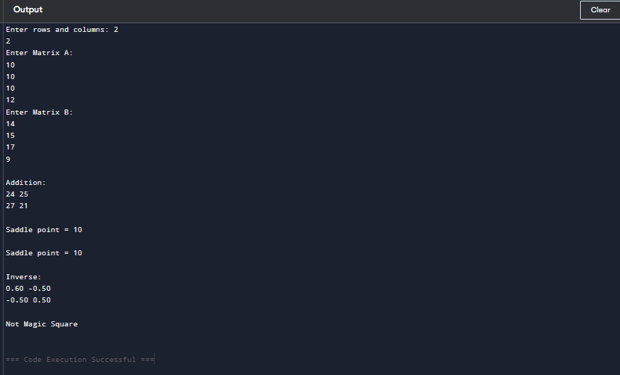

CONCLUSION:
Thus, we have learned how to perform basic matrix operations using C programming and understood their practical applications.

FAQs:
1. What is a saddle point in a matrix?
2. When does a matrix have an inverse?
3. What is a magic square?

